

# Perth College

### Semester Two Examination, 2018

### Question/Answer booklet

# MATHEMATICS

If required by your examination administrator, please place your student identification label in this box

**METHODS**

**UNITS 1 AND 2**

## Section One:

## Calculator-free

|  |  |  |  |  |  |  |  |  |  |  |
| --- | --- | --- | --- | --- | --- | --- | --- | --- | --- | --- |
| Student number: In figures |  |  |  |  |  |  |  |  |  |  |

In words

Your name

## Time allowed for this section

Reading time before commencing work: five minutes

Working time: fifty minutes

## Materials required/recommended for this section

***To be provided by the supervisor***

This Question/Answer booklet

Formula sheet

***To be provided by the candidate***

Standard items: pens (blue/black preferred), pencils (including coloured), sharpener,  
correction fluid/tape, eraser, ruler, highlighters

Special items: nil

## Important note to candidates

No other items may be taken into the examination room. It is **your** responsibility to ensure that you do not have any unauthorised material. If you have any unauthorised material with you, hand it to the supervisor **before** reading any further.

## Structure of this paper

|  |  |  |  |  |  |
| --- | --- | --- | --- | --- | --- |
| Section | Number of questions available | Number of questions to be answered | Working  time (minutes) | Marks available | Percentage of examination |
| Section One:  Calculator-free | 8 | 8 | 50 | 54 | 35 |
| Section Two:  Calculator-assumed | 13 | 13 | 100 | 96 | 65 |
|  | | |  | **Total** | 100 |

## Instructions to candidates

1. The rules for the conduct of examinations are detailed in the school handbook. Sitting this examination implies that you agree to abide by these rules.

2. Write your answers in this Question/Answer booklet.

3. You must be careful to confine your response to the specific question asked and to follow any instructions that are specified to a particular question.

4. Supplementary pages for the use of planning/continuing your answer to a question  
have been provided at the end of this Question/Answer booklet. If you use these pages to continue an answer, indicate at the original answer where the answer is continued, i.e. give the page number.

5. Show all your working clearly. Your working should be in sufficient detail to allow your answers to be checked readily and for marks to be awarded for reasoning. Incorrect answers given without supporting reasoning cannot be allocated any marks. For any question or part question worth more than two marks, valid working or justification is required to receive full marks. If you repeat any question, ensure that you cancel the answer you do not wish to have marked.

6. It is recommended that you do not use pencil, except in diagrams.

7. The Formula sheet is not to be handed in with your Question/Answer booklet.

Section One: Calculator-free 35% (54 Marks)

This section has**eight (****8)** questions. Answer **all** questions. Write your answers in the spaces provided.

Working time: 50 minutes.

Question 1 (7 marks)

(a) The first four terms of a sequence are $-1$, $3$, $-9$ and $27$.

(i) Write a recursive rule for the sequence above. (1 mark)

(ii) Write a rule for the th term. (1 mark)

(iii) Determine the value of $T_{5}$. (1 mark)

(b) The first three terms, in order, of an arithmetic sequence are $4x+3, 2x-1$ and $x-8$.

Determine the fourth term of the sequence. (4 marks)

Question 2 (6 marks)

(a) State the 4th term of ${\left(1-2x\right)}^{10}$. (3 marks)

(b) Sketch the graph of a function that satisfies all conditions below: (3 marks)

* has one root, which is the origin,
* $\begin{matrix}dy \\ \overline{dx}\end{matrix}=0$ when $x=2$ and $x=5$,
* $\begin{matrix}dy \\ \overline{dx}\end{matrix}<0$ when $2<x< 5$
* $\begin{matrix}dy \\ \overline{dx}\end{matrix}>0$ otherwise

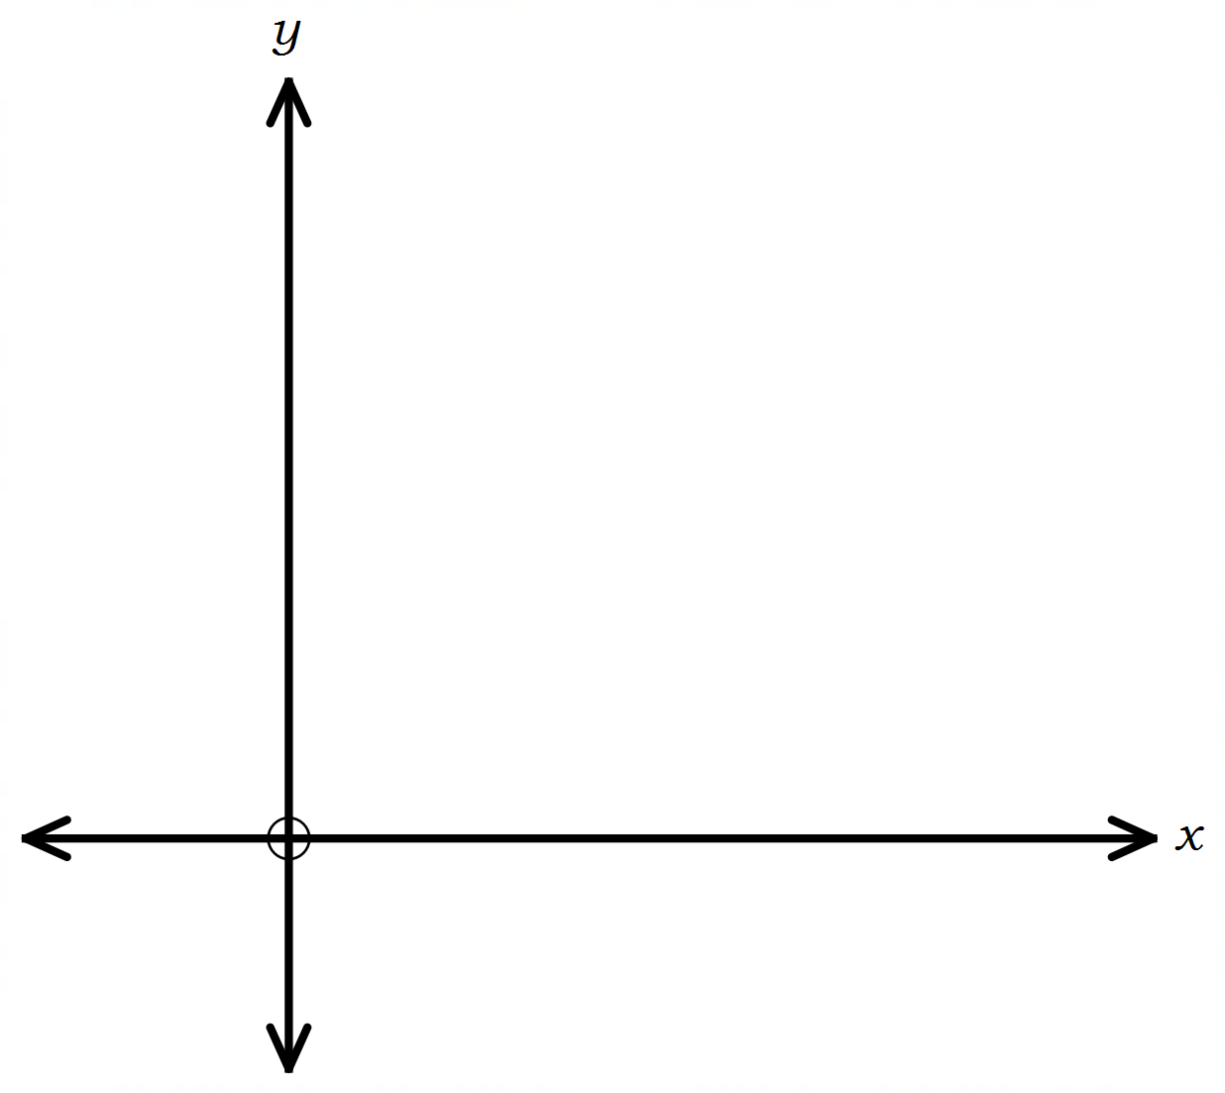

Question 3 (8 marks)

Solve each equation below for $x$.

(a) $\begin{matrix}4x \\ \overline{x-7}\end{matrix}=\begin{matrix}3 \\ \overline{2}\end{matrix}$. (2 marks)

(b) $\left(x+2\right)\left(x-2\right)=3x$. (3 marks)

(c) $2\cos{x}+\sqrt{3}=0, 0≤x≤2π$. (3 marks)

Question 4 (7 marks)

(a) Simplify

(i) $\begin{matrix}d \\ \overline{dx}\end{matrix}(2x^{5}+6x-7)$. (1 mark)

(ii) $\lim_{h→0}{\begin{matrix}{\left(x+h\right)}^{4}-x^{4} \\ \overline{ h }\end{matrix}}$. (1 mark)

(b) Determine the gradient of the tangent to the curve $y=x^{3}-4x+3$ when $x=-2$.

(2 marks)

(c) Determine $f(x)$ given $f^{'}\left(x\right)=4x-5$ and $f\left(2\right)=-3$. (3 marks)

Question 5 (6 marks)

The derivative of a cubic polynomial is given by $\begin{matrix}dy \\ \overline{dx}\end{matrix}=3x^{2}-2x-24$.

The cubic passes through the point $(-1, -14)$.

(a) Determine the equation of the cubic. (2 marks)

(b) Show that the cubic has a root when $x=-2$. (1 mark)

(c) Determine the other two roots of the cubic. (3 marks)

Question 6 (6 marks)

A small body moves in a straight line so that its displacement $x$ from a fixed point $O$ after $t$ seconds is given by $x=at^{2}+bt+c$ metres.

The position-time graph of the body is shown below.

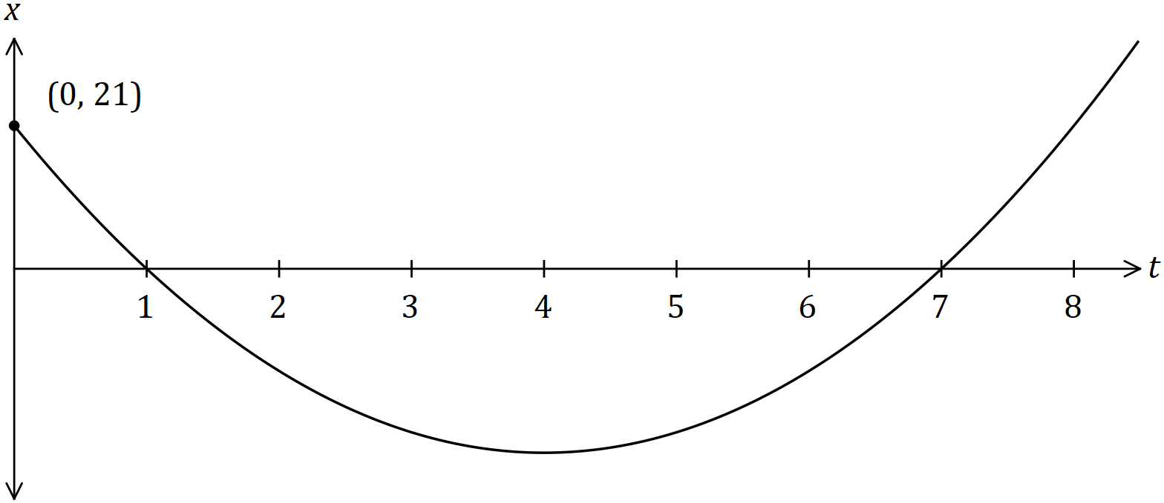

(a) Determine the values of the constants $a, b$ and $c$. (3 marks)

(b) Determine the displacement of the body when its velocity is ms-1. (3 marks)

Question 7 (6 marks)

(a) Evaluate $\begin{matrix}m^{0.5} \\ \overline{n^{2}}\end{matrix}$ when $m=4×{10}^{6}$ and $n=5×{10}^{2}$, writing your answer in simplest form without the use of scientific notation. (3 marks)

(b) Determine the value of $x$ when $4^{x}=32\sqrt{2}$. (3 marks)

Question 8 (8 marks)

Let $f\left(x\right)=x^{2}+x$.

(a) Determine the average rate of change when $x=3$ and $x=5$. (3 marks)

(b) Use first principles to determine the rate of change function $f^{'}\left(x\right)$ (5 marks)

Supplementary page

Question number: _________

|  |  |  |
| --- | --- | --- |
| **Markers use only** | | |
| **Question** | **Maximum** | **Mark** |
| 1 | 7 |  |
| 2 | 6 |  |
| 3 | 8 |  |
| 4 | 7 |  |
| 5 | 6 |  |
| 6 | 6 |  |
| 7 | 6 |  |
| 8 | 8 |  |
| **S1 Total** | **54** |  |
| **S1 Weighted** | **35%** |  |
| **S2 Weighted** | **65%** |  |
| **Total** | **100%** |  |

© 2018 WA Exam Papers. Perth College has a non-exclusive licence to copy and communicate this document for non-commercial, educational use within the school. No other copying, communication or use is permitted without the express written permission of WA Exam Papers. SN077-122-1.